# Use Case Diagram

# for the Pool Access System (PAS) project

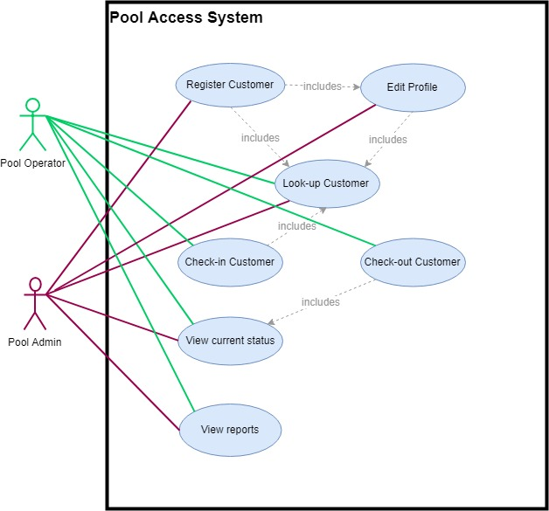

## Contributing members

* Dmitry Mikhailov
* David Ortiz
* Drew Hopkins
* Joe Hackett